第三课语法功课 姓名___________________ 成绩_____________  
一、填写申报单。(Information does have to be real.)

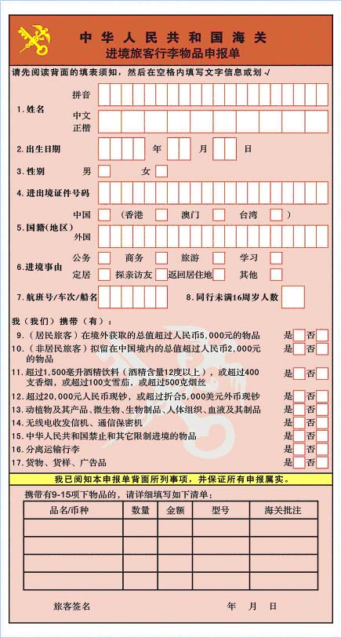  
  
二、把英文对话翻译成中文。  
1. New student: How long does it take to drive from our school library to Wal-Mart?  
Return student: Very fast. Less than 10 minutes.

2. Male Traveler: How long does it take to go through (过v. to pass) the Customs?  
 Female Traveler: Very long. It will take about 90 minutes.  
  
  
  
3. New tenant新房客: How big is our apartment?  
 Return tenant 老房客：Not very big. It’s about 400 foot.

（Use verb + 起来 from sentence 4-8）  
4. My Mom said that I am getting chubby.  
  
  
5. Students say, “To say it is easy, to do it is hard.”  
  
  
6. I can’t recall where we have met before.

7. You look very tired today. What happened?

8. Answer the questions by looking at the picture. Start from 你从+place + 出来…, end with 你就到了。Include 往。。。转、过、路口，先。。，再。。。，然后，。。。  
 问题：从电影院到超市怎么走？ 回答：

|  |  |
| --- | --- |
|  |  |